**Theme no. 2**

**Smart Marketing**

**Gherghe Tudor-Alexandru**

**Oloeriu Delia-Ioana**

**Content:**

1. Applicability domains
   1. use-cases (minim 4, maxim 8);
   2. one of the use cases is chosen and the system is defined in detail;
2. System definition:
   1. components that enter the system infrastructure;
   2. protocols used in communication processes;
   3. process automation;
   4. estimated costs;
3. Cisco Packet Tracer:
4. add a print screen of the designed architecture;
5. explain the functionalities implemented in Cisco Packet Tracer;
6. TinkerCad:
7. add a print screen of the designed architecture;
8. explain the functionalities implemented in TinkerCad.
9. **Applicability domains**
   1. **use-cases**

1. Smart shopping cart

2. Stock management

3. Client app for finding products in the store, getting suggestions, and checking how busy the shop is

4. Smart shelves

* 1. **Smart shopping cart**

The smart shopping cart has a screen that people can connect to their customer app by scanning a QR Code. The shopping cart has a scanner that determines what products you put in and out of it and will also automatically make the payment when exiting the store.

1. **System definition:** 
   1. **components that enter the system infrastructure;**

* a screen for the shopping cart that can connect to the app
* a barcode scanner
* GPS sensor
* Internet connection
* a shopping cart
  1. **protocols used in communication processes;**
* the GPS sensor has a wired connection to the screen
* the barcode scanner has a wired connection to the screen
* the Internet is used to access the cloud for resource management reasons
  1. **process automation;**
* the items introduced in the shopping cart are automatically scanned
* the payment is automatically done once you exit the store
  1. **estimated costs;**
* shopping cart: 150 $
* GPS sensor: 2 $
* barcode scanner: 100 $
* screen: 100 $

Total: 352 $ / shopping cart

1. **Cisco Packet Tracer:**
2. **add a print screen of the designed architecture;**

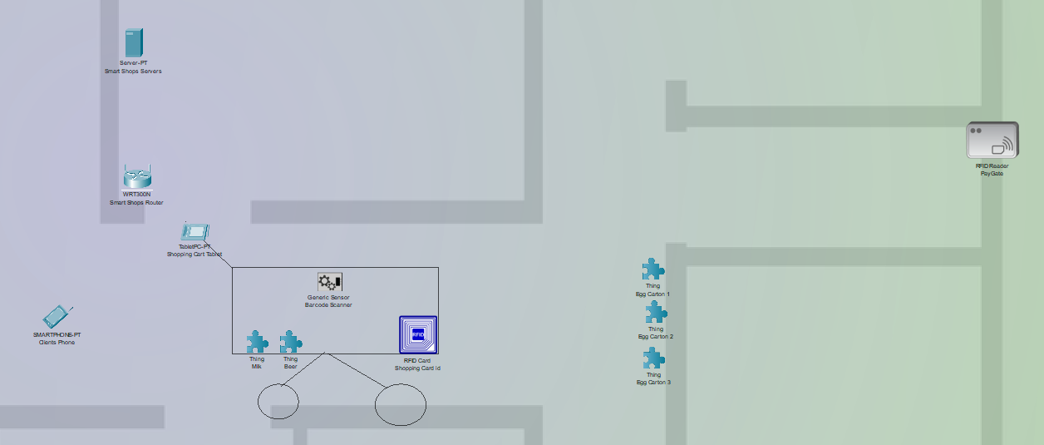

1. **explain the functionalities implemented in Cisco Packet Tracer;**

* Internet Connection for data transfer connecting the tablet with a database [implemented]:
  + The tablet sends data to the server about the products in the shopping card;
  + The server offers data to the tablet about the shop’s available stock and offers.
* Product scanning:
  + Every product has an RFID card with info regarding its product id;
  + Every cart has an RFID scanner ;
  + When a product enters the shopping cart it is identified and counted on the current list of products in that cart.
* Checking out:
  + Every shopping cart has an RFID card with its shopping cart id;
  + The exit gate has an RFID scanner for identifying the passing shopping carts. The algorithm then identifies the connected user on that cart and starts the payment process.

1. **TinkerCad:**
2. **add a print screen of the designed architecture;**

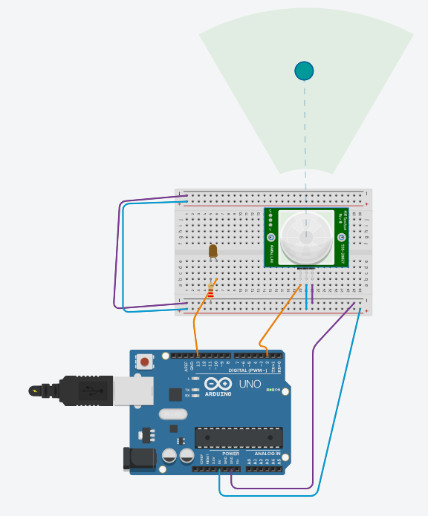

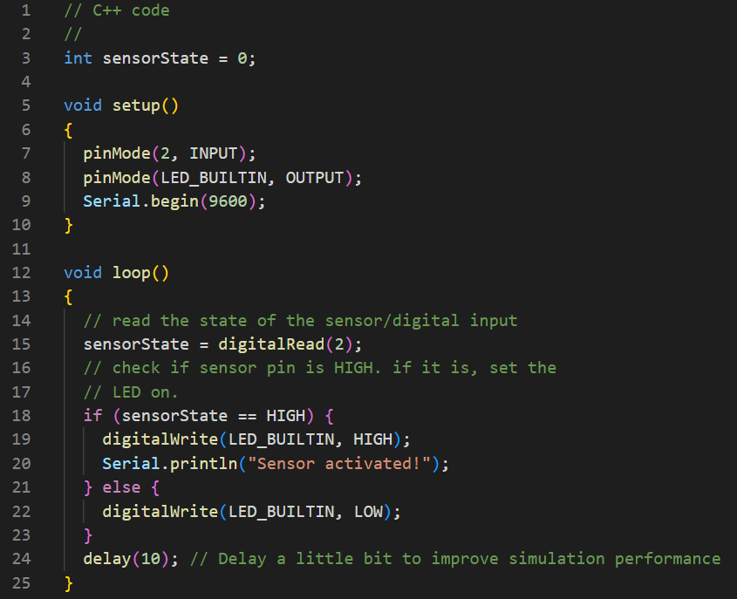

1. **explain the functionalities implemented in TinkerCad.**

* The TinkerCad application contains a motion sensor that send a signal to the Arduino when triggered
* The Arduino receives the signal and lights up the connected LED